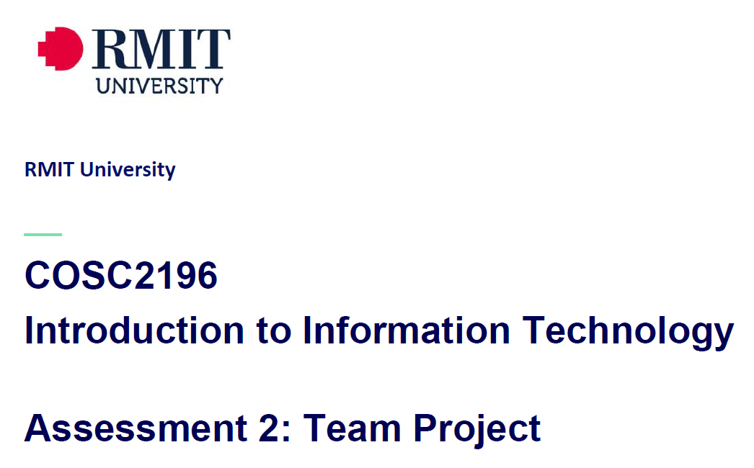
A2, Group #4 MEETING
Venue: Online via MS Teams
Date: 31/3/21

Minutes

Meeting Opened: (time)
Attendance: Paul Eccarius, Rebecca Watson, Martin Lee, Nour Zeroual, Jarrad Hofman-Agar
Apologies:
- Welcome and Introductions

- Correspondence:
- Bec contacted Umera via email (as copy-pasted into the team chat) re: inactive members of the group. This meeting will meet the 48 hour deadline for their response – have we heard back from them?

- Has everyone had a chance to read through the Assignment?

- Do we want to appoint a Team Leader for A2?

- Team Profile

- Ideal Jobs

- Tools

- Industry Data

- IT Work

- IT Technologies

- Project Ideas

- Additional points for discussion?

Next meeting date:
Meeting closed: (time)

Actions Register

Meeting Date | Action | Who to action | Completed Y/N | Update at meeting | Further action

